Name: INIGASHREE N S

College: Kongu Engineering College

**EXERCISE 1: LOGGING ERROR MESSAGES AND WARNING LEVELS**

This Java program demonstrates how to log error and warning messages using **SLF4J** (Simple Logging Facade for Java) in a **weather monitoring system**. It simulates weather sensor readings and generates informative logs to assist in system diagnostics and environmental alerting.

**Objective:**

• **Log Critical Failures**  
Capture and log errors such as API outages or sensor read failures using logger.error() to alert system administrators or monitoring dashboards.

• **Warn About Risk Conditions**  
Use logger.warn() to notify about high temperatures, low humidity, or freezing conditions that may require user intervention.

• **Improve Observability**  
Provide real-time visibility into system conditions through structured logs, enabling better monitoring, debugging, and proactive system maintenance.

**Code & Output:**

**WeatherMonitor.java**

package org.example;  
  
import org.slf4j.Logger;  
import org.slf4j.LoggerFactory;  
  
public class WeatherMonitor {  
  
 private static final Logger *logger* = LoggerFactory.*getLogger*(WeatherMonitor.class);  
  
 public static void main(String[] args) {  
 double temperature = *readTemperatureSensor*();  
 double humidity = *readHumiditySensor*();  
 boolean apiDown =true; // Set true to simulate API failure  
  
 System.*out*.println("Weather Report:");  
 System.*out*.println("Temperature: " + temperature + "°C");  
 System.*out*.println("Humidity: " + humidity + "%");  
  
 if (apiDown) {  
 *logger*.error("Weather API is not responding...");  
 System.*out*.println("Error: Cannot retrieve live weather data.");  
 }  
  
 if (temperature > 40) {  
 *logger*.warn("High temperature detected: {}°C", temperature);  
 }  
  
 if (humidity < 20) {  
 *logger*.warn("Low humidity level detected: {}%", humidity);  
 }  
 }  
  
 private static double readTemperatureSensor() {  
 return 42.8; // Simulated value  
 }  
  
 private static double readHumiditySensor() {  
 return 15.5; // Simulated value  
 }  
}

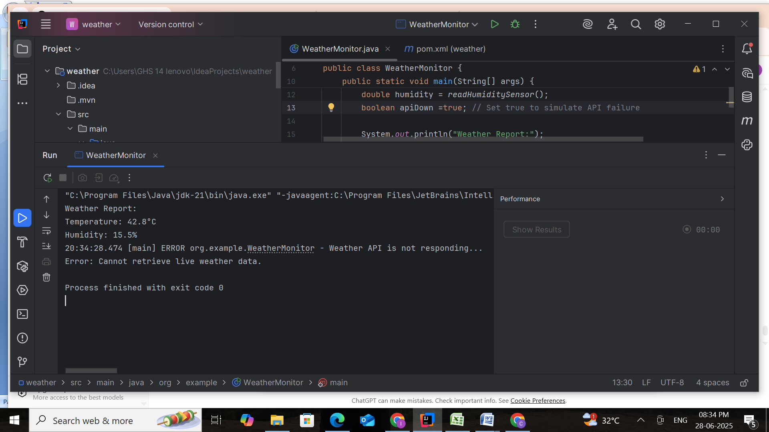

The program effectively demonstrates how SLF4J can be used to differentiate between error and warning levels in a real-world scenario. This structured logging aids in quick debugging, system monitoring, and maintaining reliable software performance.